**Table S5.** External validation data estimation performance of amikacin pharmacokinetic parameters

|  |  |  |  |  |  |  |  |  |  |  |  |  |
| --- | --- | --- | --- | --- | --- | --- | --- | --- | --- | --- | --- | --- |
| **Sampling time** |  | **Peak** | |  | **Trough** | |  | **Peak and trough** | |  | **Every 1h** | |
|  | **MPE** | **RMSE** |  | **MPE** | **RMSE** |  | **MPE** | **RMSE** |  | **MPE** | **RMSE** |
| **Single** **dose** |  |  |  |  |  |  |  |  |  |  |  |  |
| CL(L/h) |  | 17.93 | 0.93 |  | -2.11 | 0.34 |  | 1.83 | 0.34 |  | 1.34 | 0.22 |
| V(L) |  | -5.24 | 2.49 |  | -14.64 | 3.15 |  | -1.60 | 2.48 |  | -1.51 | 1.75 |
| **Steady-state** |  |  |  |  |  |  |  |  |  |  |  |  |
| CL(L/h) |  | 17.00 | 0.70 |  | -4.71 | 0.29 |  | -1.24 | 0.24 |  | -0.49 | 0.14 |
| V(L) |  | -18.35 | 3.91 |  | -14.43 | 3.31 |  | -6.74 | 2.83 |  | -4.83 | 2.53 |

**Abbreviations:** CL, clearance; V, volume of distribution.

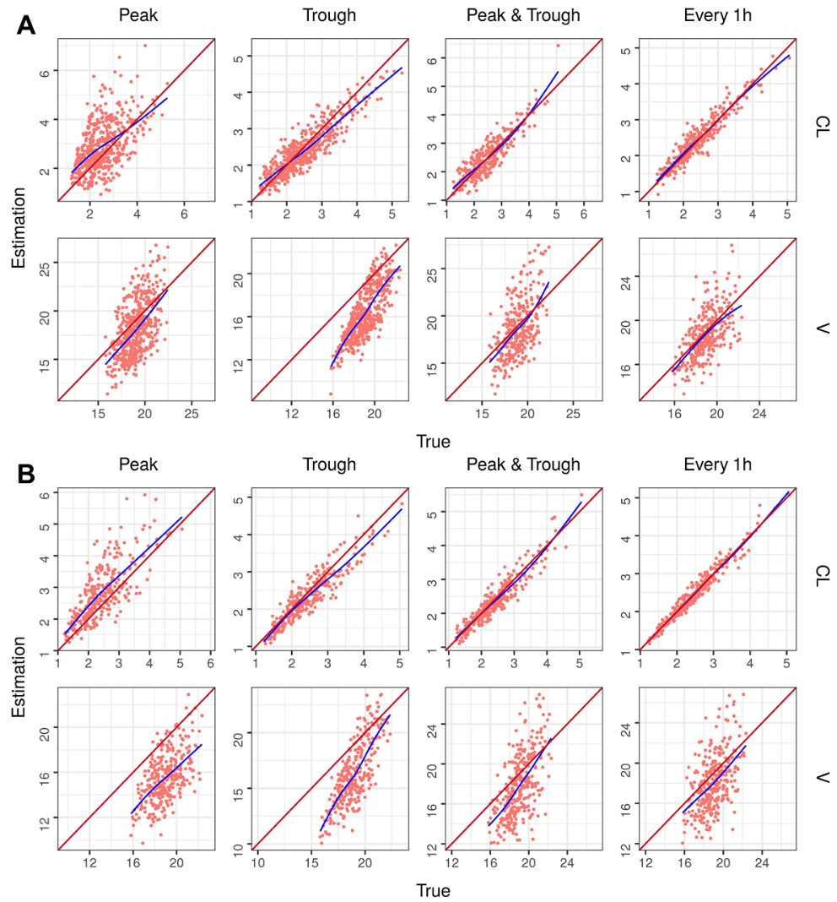

**Figure S5.** Graphs representing the amikacin parameters estimated versus true values in each external validation scenario. The identity line is shown in red and a trend line in blue has been drawn for each model. (**A**) Signal dose. (**B**) Steady state. **Abbreviations:** CL, clearance; V, volume of distribution.

**Table S6.** External validation data estimation performance of vancomycin pharmacokinetic parameters

|  |  |  |  |  |  |  |  |  |  |  |  |  |
| --- | --- | --- | --- | --- | --- | --- | --- | --- | --- | --- | --- | --- |
| **Sampling time** |  | **Peak** | |  | **Trough** | |  | **Peak and trough** | |  | **Every 1h** | |
|  | **MPE** | **RMSE** |  | **MPE** | **RMSE** |  | **MPE** | **RMSE** |  | **MPE** | **RMSE** |
| **Single dose** |  |  |  |  |  |  |  |  |  |  |  |  |
| CL(L/h) |  | 72.84 | 2.12 |  | 115.45 | 1.93 |  | 121.10 | 1.99 |  | 173.72 | 2.81 |
| Vc (L) |  | -60.05 | 19.16 |  | -62.17 | 19.84 |  | -60.93 | 19.44 |  | -56.13 | 17.92 |
| k12 (1/h) |  | 263.78 | 0.99 |  | 210.68 | 0.78 |  | 244.90 | 0.92 |  | 231.08 | 0.88 |
| k21 (1/h) |  | 228.77 | 0.29 |  | 243.64 | 0.30 |  | 227.73 | 0.29 |  | 211.71 | 0.27 |
| **Steady-state** |  |  |  |  |  |  |  |  |  |  |  |  |
| CL(L/h) |  | 11.33 | 1.19 |  | -3.43 | 1.14 |  | -3.72 | 0.90 |  | -4.19 | 0.41 |
| Vc (L) |  | -62.55 | 19.96 |  | -61.98 | 19.79 |  | -61.57 | 19.65 |  | -58.82 | 18.78 |
| k12 (1/h) |  | 202.43 | 0.75 |  | 209.86 | 0.77 |  | 221.82 | 0.83 |  | 241.30 | 0.90 |
| k21 (1/h) |  | 257.83 | 0.32 |  | 255.62 | 0.32 |  | 246.66 | 0.31 |  | 242.22 | 0.31 |

**Abbreviations:** CL, clearance; Vc, central volume of distribution; k12, first-order transfer rate constant from the central compartment to peripheral compartment; k21, first-order transfer rate constant from the peripheral compartment to central compartment.

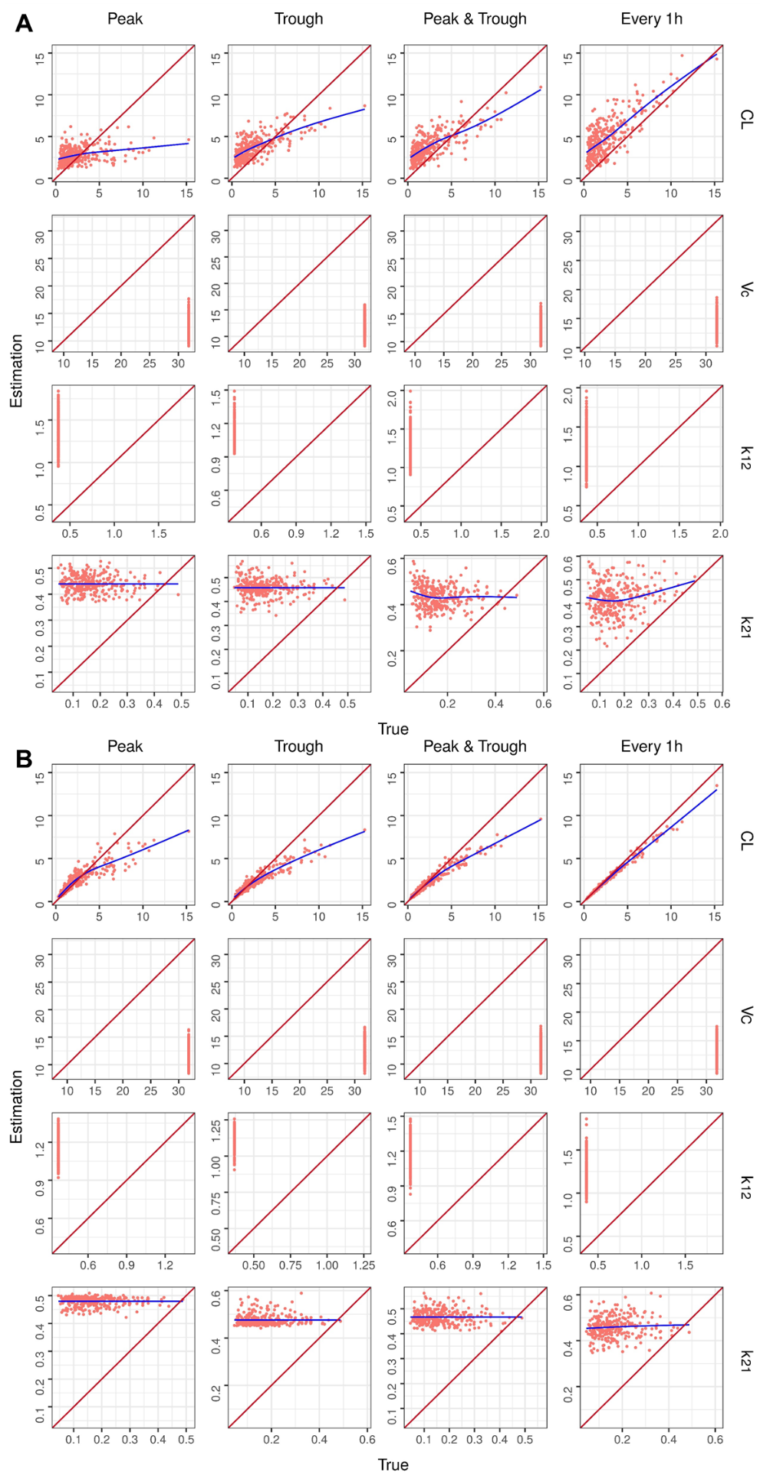

**Figure S6.** Graphs representing the vancomycin parameters estimated versus true values in each external validation scenario. The identity line is shown in red and a trend line in blue has been drawn for each model. (**A**) Signal dose. (**B**) Steady state. **Abbreviations:** CL, clearance; Vc, central volume of distribution; k12, first-order transfer rate constant from the central compartment to peripheral compartment; k21, first-order transfer rate constant from the peripheral compartment to central compartment.

**Table S7.** External validation data estimation performance of theophylline pharmacokinetic parameters

|  |  |  |  |  |  |  |  |  |  |  |  |  |
| --- | --- | --- | --- | --- | --- | --- | --- | --- | --- | --- | --- | --- |
| **Sampling time** |  | **Peak** | |  | **Trough** | |  | **Peak and trough** | |  | **Every 1h** | |
|  | **MPE** | **RMSE** |  | **MPE** | **RMSE** |  | **MPE** | **RMSE** |  | **MPE** | **RMSE** |
| **Single dose** |  |  |  |  |  |  |  |  |  |  |  |  |
| CL/F (L/h) |  | -25.03 | 1.36 |  | -22.04 | 1.25 |  | -22.00 | 5.30 |  | 1.22 | 4.62 |
| V/F (L) |  | 75.12 | 14.67 |  | 52.38 | 10.58 |  | 84.64 | 0.06 |  | 1.69 | 0.04 |
| **Steady-state** |  |  |  |  |  |  |  |  |  |  |  |  |
| CL/F (L/h) |  | -19.41 | 1.13 |  | -22.62 | 1.14 |  | -17.68 | 3.55 |  | 0.71 | 1.80 |
| V/F (L) |  | 47.39 | 9.75 |  | 40.13 | 8.67 |  | 45.31 | 0.07 |  | 2.15 | 0.07 |

**Abbreviations:** CL/F, apparent clearance; V/F, apparent volume of distribution.

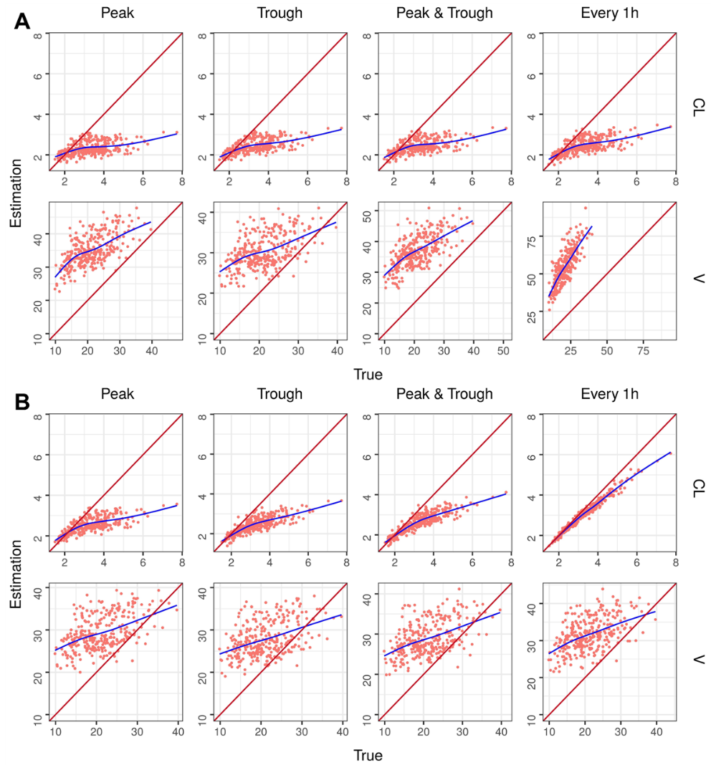

**Figure S7.** Graphs representing the theophylline parameters estimated versus true values in each external validation scenario. The identity line is shown in red and a trend line in blue has been drawn for each model. (**A**) Signal dose. (**B**) Steady state. **Abbreviations:** CL, apparent clearance; V, apparent volume of distribution.

**Table S8.** External validation data estimation performance of phenytoin pharmacokinetic parameters

|  |  |  |  |  |  |  |  |  |  |  |  |  |
| --- | --- | --- | --- | --- | --- | --- | --- | --- | --- | --- | --- | --- |
| **Sampling time** |  | **Peak** | |  | **Trough** | |  | **Peak and trough** | |  | **Every 1h** | |
|  | **MPE** | **RMSE** |  | **MPE** | **RMSE** |  | **MPE** | **RMSE** |  | **MPE** | **RMSE** |
| **Single** **dose** |  |  |  |  |  |  |  |  |  |  |  |  |
| Vmax (mg/kg/d) |  | 4.47 | 69.60 |  | 5.04 | 69.41 |  | 5.42 | 70.88 |  | 8.39 | 79.02 |
| km (mcg/mL) |  | -41.83 | 4.77 |  | -42.03 | 4.77 |  | -42.18 | 4.78 |  | -43.27 | 4.86 |
| Vnr (L/kg) |  | -28.13 | 39.01 |  | -29.75 | 41.90 |  | -27.39 | 38.23 |  | -20.91 | 28.65 |
| **Steady**-**state** |  |  |  |  |  |  |  |  |  |  |  |  |
| Vmax (mg/kg/d) |  | -11.71 | 84.73 |  | -11.82 | 85.13 |  | -12.29 | 87.37 |  | -12.96 | 90.84 |
| km (mcg/mL) |  | -40.53 | 4.64 |  | -40.16 | 4.62 |  | -40.16 | 4.62 |  | -40.02 | 4.62 |
| Vnr (L/kg) |  | -30.18 | 43.25 |  | -29.92 | 43.00 |  | -30.06 | 42.89 |  | -29.82 | 42.68 |

**Abbreviations:** Vmax, maximum velocity; km, Michaelis constant; Vnr, distribution volume independent of renal function.

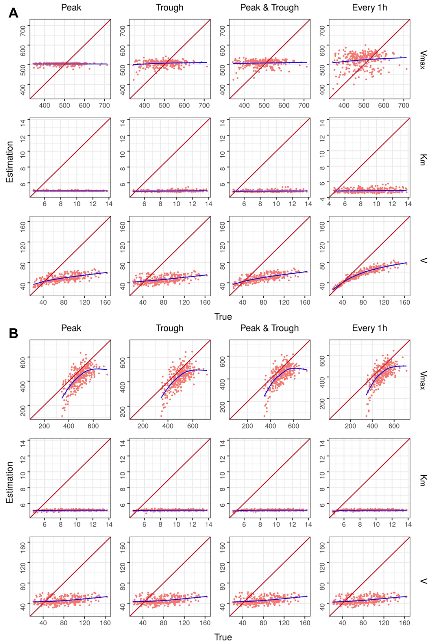

**Figure S8.** Graphs representing the phenytoin parameters estimated versus true values in each external validation scenario. The identity line is shown in red and a trend line in blue has been drawn for each model. (**A**) Signal dose. (**B**) Steady state. **Abbreviations:** Vmax, maximum velocity; km, Michaelis constant; Vnr, distribution volume independent of renal function.